**School of Information Studies**

**The Syracuse University**

**MS Applied Data Science**

**Portfolio Milestone**

Himadri Tewari – [hstewari@syr.edu](mailto:hstewari@syr.edu)

SUID – 227851541

<https://github.com/hstewari>

# **Table of Contents**

**Table of Contents** 2

Program Learning Goal 3

Projects 4

IST 652 - Analysis of New York City Current Job Postings 4

Data Collection: 4

Data Preprocessing 4

Data Analysis 4

Ethical Dimension: 7

IST 736 - Analysis of Employee Reviews: Amazon, Apple, Facebook, Google, Microsoft, and Netflix 8

Data Collection: 8

Data Preprocessing: 8

Data Analysis: 8

Models: 9

Ethical Dimension: 10

IST 707 - Analysis of Readmission rates in U.S Hospitals 10

Data Collection: 10

Data Cleaning: 10

Data Analysis: 10

Models: 12

Classification Techniques: 18

Ethical Dimension: 26

IST 659 - Database for an Online Pizza Company 26

Conceptual Model: 27

Normalized Logical Model: 27

SQL DDL Commands: 28

SQL DML Commands: 31

GUI Prototype: 32

Ethical Dimension: 33

Conclusion 34

# Program Learning Goal

In today’s world, due to the rapid growth of technology and development of the Internet community, a large amount of valuable and complex data is growing exponentially and is expected not to slow down anytime soon. There are two aspects of utilizing big data. One would be to use the data to design new processes for data modeling and prediction using predictive models, and another would be to explore the data and identify the trends, hidden pattern, design charts, and visuals and help the organization to take correct strategic decision.

In general, data analysis refers to the process of inspecting the raw data, converting it by cleaning, transforming and modeling with the objective of identifying useful information, suggesting collections and supporting decision making. The data is the main requirement which can be collected as a sample from the population. All the related variables regarding the population need to be specified. Data can be structured or unstructured, numerical or categorical. The data can be collected from a variety of sources like the internet, documents, social media platforms. The data collected need to be processed and organized by adding or modifying to include rows and columns in a tabular structure. Once the data is processed, then it is cleaned by correcting any incomplete, duplicate or error related to the data.

Data science is used to address big data which includes data collection, cleansing, preparation, and analysis. The data collected from multiple sources and platforms and machine learning models are applied to do predictive analysis and building complex algorithms. The analysis helps to excerpt useful information from the data which would help the organization to take proper business strategy.

The learning goals in the Applied Data Science program are – Data Collection, Data Analysis, Strategy & decisions, and Implementation. To showcase that I have achieved these goals, I have selected some of the projects which I have done during the course program either in a group or individually. The reasons for selecting these projects are that through these projects, I can demonstrate my knowledge of creating a database, creating conceptual and normalized logical model, apply SQL DDL & DML commands, collect data, clean up the data, analyze it to find patterns, and charts, apply different machine learning models and do the prediction. Using the data analysis and prediction model to come up with the proper suggestion and conclusion.

# Projects

# IST 652 - Analysis of New York City Current Job Postings

The goal of this work is to apply data analysis techniques to the job posting data. The job posting is one of the platforms to communicate to the public about any vacancy that an organization needs to fill up. The posting provides the applicants a good perspective about the job, which includes the job description which contains broad details of what the position is for. The posting also communicates to the public what is needed in the person to fulfill the job. To fulfill the job-seeking position and to find the correct person, many organizations hired employment agencies who help with its staffing needs. Employment agencies post the job vacancies on the job posting platforms like Glassdoor, Indeed, Dice or LinkedIn, mentioning the job details

## Data Collection:

The dataset is collected from the Kaggle website (<https://www.kaggle.com/new-york-city/new-york-city-current-job-postings>) which contains job posting available in the City of New York’s official job site. The data is hosted in open data platform – NYC Open Data which contains over 1200 datasets with new data added every day (<https://opendata.cityofnewyork.us/>). This dataset is updated weekly. The initial dataset has twenty-eight attributes. It contains the name of the agency, posting type, number of positions, job category, full time or part-time, salary range and frequency. It also contains additional important attributes which focuses more on the posting details like minimum qualification required, preferred skills, work location, and the posting dates. It also contains the instruction to apply and additional information.

## Data Preprocessing

For this project, as part of the data preprocessing, the following list of important libraries are imported. Pandas are imported for data manipulation and analysis. Numpy is imported for scientific computation. Matplotlib and seaborn are imported for visualization purpose. Wordcloud is imported to generate the word-cloud. Nltk is imported for stopwords. “re” library is imported for the regular expression. Gmap is imported to visualize the map. The dataset was collected in CSV format, so to read the data, pandas ‘read_csv’ function was used.

## Data Analysis

As part of the data analysis process, data comparison was done for some of the attributes like Posting Types, Full Time/Part-Time Indicator and Salary Frequency.

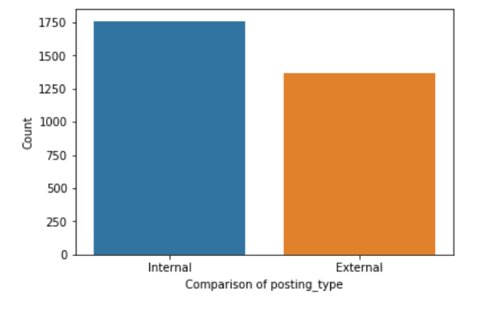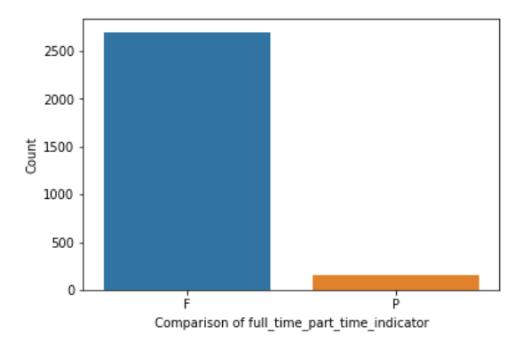

The next analysis was done to find out the top counts of attributes like Agency, Civil Service Title, Business Title, Job Categories. The data was further analyzed using some of the attributes like Preferred Skills and Minimum Qualification. As all these attributes contain text data, so the word cloud was generated to visualize the frequency and the importance of each word. To generate the correct word cloud, the stop words are removed, and for that stopwords package was imported from nltk library.

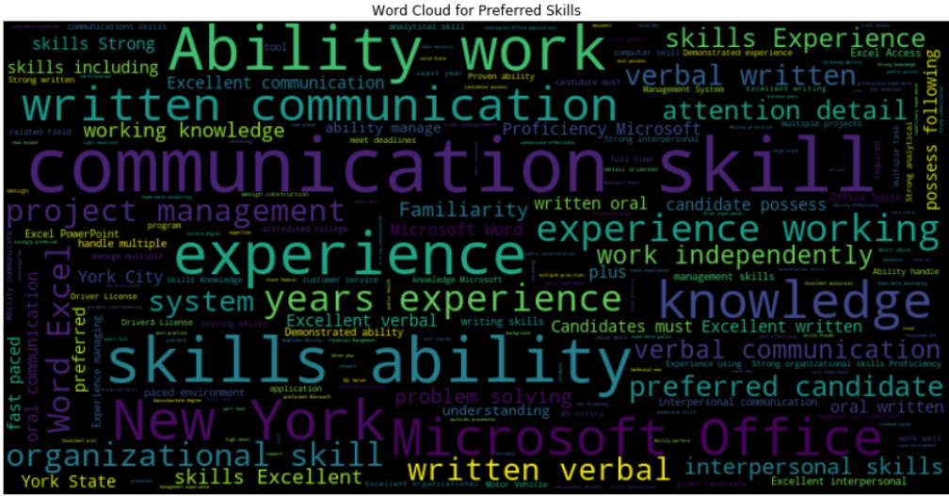



To further analyze the data, the date columns – posted date, process date, and posting date were converted into date-time objects. From the posted date column, the year and the months were extracted and added as two separate columns. Using the month and year column, yearly and monthly trend of the number of positions were visualized.

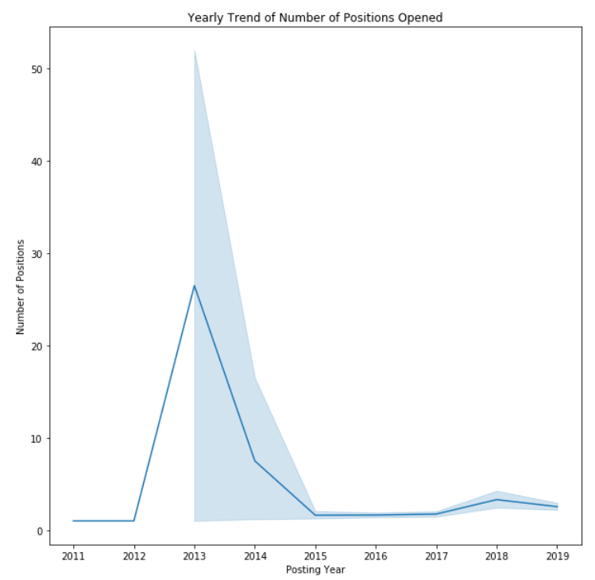

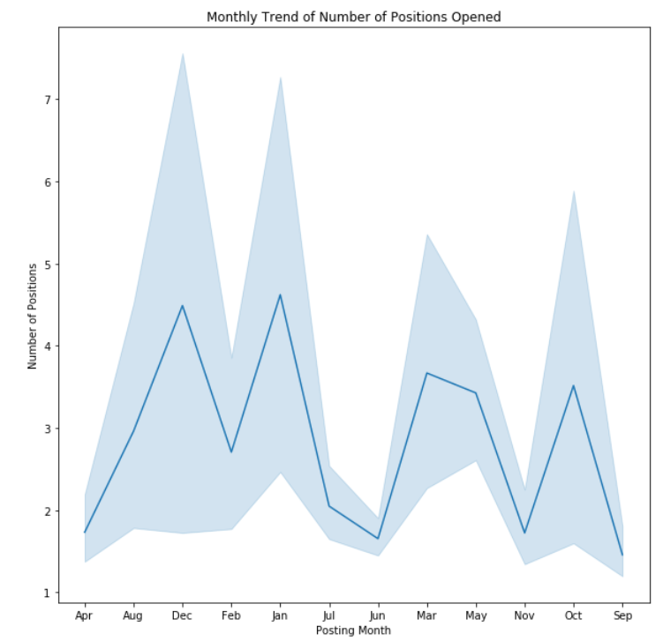

To do the map-based spatial analysis, the work address and the counts were then converted to dataframe. Using the geopy library, the coordinates of the address were generated. The coordinates column was then broken into two more columns – latitude and longitude. Then, using the folium library, the agency’s work address was generated on the map.

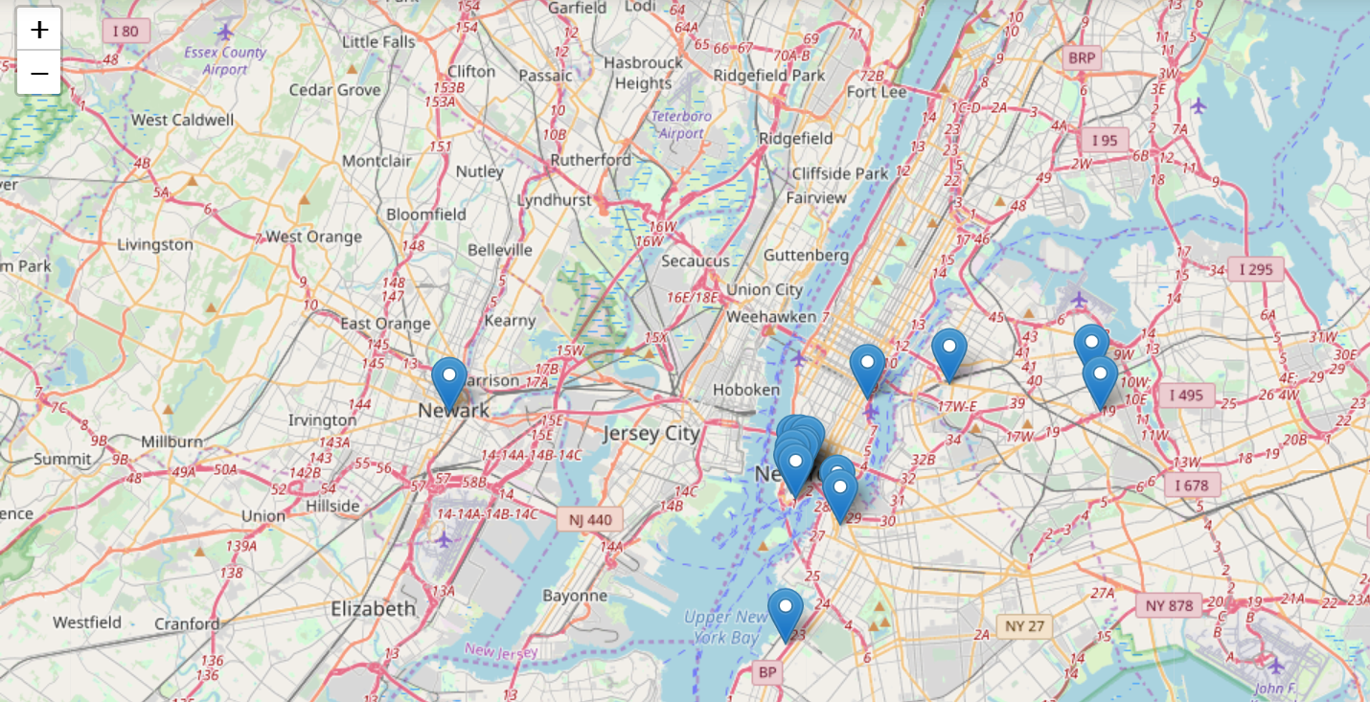

## Ethical Dimension:

The data used for this project does not contain any personal details like name or phone number or home address. The only data available was the agency work location address which would not impact on the privacy of any individual.

# IST 736 - Analysis of Employee Reviews: Amazon, Apple, Facebook, Google, Microsoft, and Netflix

The goal of this project was to apply text mining techniques to employee reviews analysis. Employee feedback is one of the most important resources for job-seekers. Employees provided feedback are used by potential job-seekers to find objective, unbiased information about working at a particular company. If anyone is looking for a job, he/she will be referring to the employee review sites before applying to the company. Nowadays, people are interested not only in big salaries or attractive perks but also the work environment the company provides. A poor work environment could bring negative results like low employee morale, high turnover, and bad social media feedback which impact the number of people applying for jobs at those companies. Moreover, employee feedback and rating websites like Glassdoor or Indeed help the job seekers to research and understand how competitive a job or the company itself before accepting the offer. It also helps the job seekers to view which type of jobs are getting more attention and thus which company is looking for that kind of jobs. Employee feedback on the websites also help the employer or the companies to understand the pain points which employees have provided in their feedback and hence provide the company to restructure their infrastructure, benefits and work environment, to not only getting the talented resources but also to retain the existing employees.

## Data Collection:

The dataset was collected from the Kaggle website which contains 67k employee reviews for Google, Amazon, Netflix, Facebook, Apple, and Microsoft. The original dataset was collected from Glassdoor – a website where current and former employees provide feedback for their companies and management. The data source currently has been removed from the Kaggle. The initial dataset has sixteen attributes. It contains the name of the company, review posting location, review posting date, current or former employee type, a summary of the review, pros and cons. It also contains additional important attributes which focuses more on the organization health like the company’s work environment, benefits provided to the employees and the senior management team. These attributes are measured on a scale of 1 to 5, with 1 being the poor rating and 5 being the highest. These attributes are overall rating, work-life balance rating, culture, and values rating, career opportunities rating, compensation, and benefits rating and senior management rating. It also contains the total number of review counts and link to the reviews.

## Data Preprocessing:

For this project, as part of the data preprocessing, the following list of important libraries are imported. Random is imported for cross-validation and splitting the data into train and test set. Pandas library is imported for data manipulation and analysis. Numpy is imported for scientific computation. Matplotlib and seaborn are imported for visualization purpose. Wordcloud is imported to generate the word-cloud. Sci-kit and nltk are imported for data preprocessing and model formation. The dataset was collected in CSV format, so to read the data pandas ‘read_csv’ function was used.

## Data Analysis:

Data analysis focuses on systematically applying statistical and/or logical techniques on the existing dataset. The process involves multiple steps that include extracting and categorizing the dataset to generate different patterns, relations, connections, and other such valuable insights from it. First, a summary of the overall rating distribution was measured for each of the companies. The next analysis was done analyzing the number of reviews for each company. To explore more on the data, the review count of former employees is compared with the current employees for each of the companies. To explore the employee types and their feedback process, the data was analyzed to find out which employee type has given the highest rating to each of the companies. The dataset was further analyzed to find out the distribution of stars in a rating scale of one through five. To analyze more on the review comments, the word cloud was generated to analyze the weight of the texts present in the review comments. To generate the word cloud for the dataset, first, all the punctuations were removed. After removing the punctuations, the stop words are also removed. The word tokens were then lemmatized using the WordNetLemmatizer function. Then for each of the company’s pros and cons attributes, top twenty words were generated.

## Models:

To see if a model can learn from the data to correctly recognize the employee attitude based on pure textual information, Multinomial Naïve Bayes and Support Vector Machine models were applied. Several metrics were used to measure the prediction like accuracy, f-measure, precision and recalls. The major indicator is the average accuracy because the sentiment analysis is actually a binary text classification task. For others' convenience to reproduce the same experiments, the random seed is fixed as 0, the same as what used for splitting out validate set. Both models are implemented with the help of modules offered by Scikit-learn. After applying and training both the models, finally, SVM with Uni & Bi Countvectorizer achieved 88.6% average accuracy over 10 folds cross-validation, whereas MNB achieved 87.3% accuracy with the alpha of 0.1.

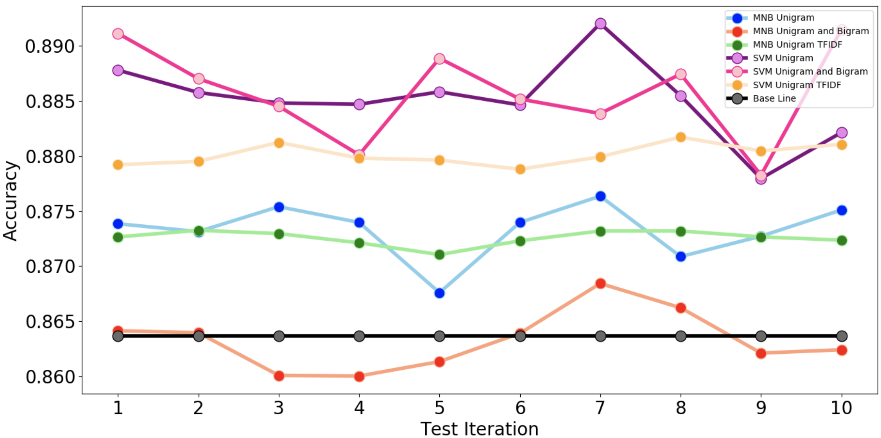

## Ethical Dimension:

The data used for this project contains the review comments of the current and formal employees of the organizations which would affect the brand value of the companies. The dataset was collected from Kaggle but was later removed from the website due to the nature of the data.

# IST 707 - Analysis of Readmission rates in U.S Hospitals

The objective of this project was to analyze the readmission rates in the hospitals based on Hyperglycemia, a characteristic of diabetes—when the blood glucose level is too high because the body doesn't make the hormone insulin. Eating too many processed foods may cause blood sugar to rise and high blood sugar (hyperglycemia) affects people who have diabetes. There are several factors can cause hyperglycemia in people with diabetes, which includes physical activity choices, illness, non-diabetes medications, food habits or not taking enough glucose-lowering medication.

## Data Collection:

The data was collected from Health Facts database, a national data warehouse that collects comprehensive clinical records across hospitals throughout the United States. Dataset represents 10 years (1999-2008) of clinical care at 130 US hospitals and integrated delivery networks. The data aims to analyze factors related to readmission as well as other outcomes pertaining to patients with diabetes. The original dataset has about 100,000 rows of data. Dataset was reduced to 50,000 rows since the original one is too large.

## Data Cleaning:

As always, it’s imperative to clean the data as much as possible before doing any sort of analysis on the data. Unimportant attributes like encounter id and patient number were removed since they are not going to contribute anything to the analysis. Some of the attributes were removed due to a lot of missing values. Also, the columns having NA’s were converted to zero. Also, some of the attributes were recoded to numbers or characters for better analysis. Some of the attributes like num procedures were discretized as below:

* If the number of procedures done on the patient is less than or equal to three -> 1
* If the number of procedures done on the patient greater than three -> 2

Attribute ***num lab procedures*** were discretized as below:

## Data Analysis:

Different attributes were selected and visualized to see their ranges and what stories the data tells. The below bar chart visualizes the readmission rates by age and shows how patients in their sixties and seventies are the ones with higher readmission rates and those are the same sector of patients who have high percentages of no readmission rates as well.

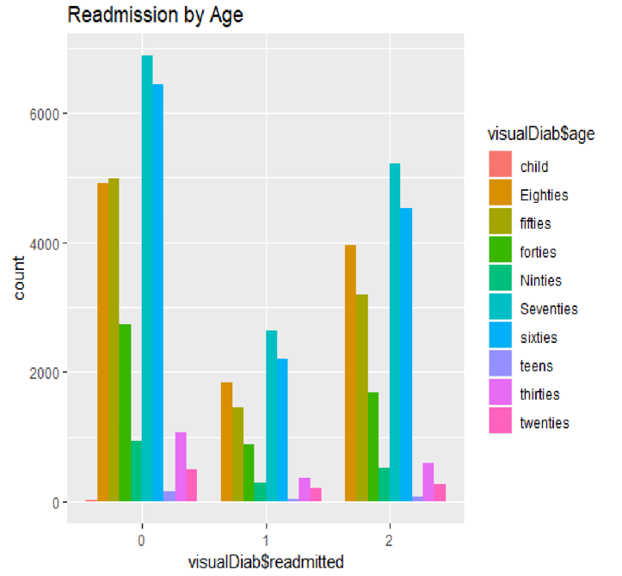

The below bar plot visualizes the readmission rates by diabetes medications where the highest number of patients in any category of readmission are the ones who were ordered to take the medications.

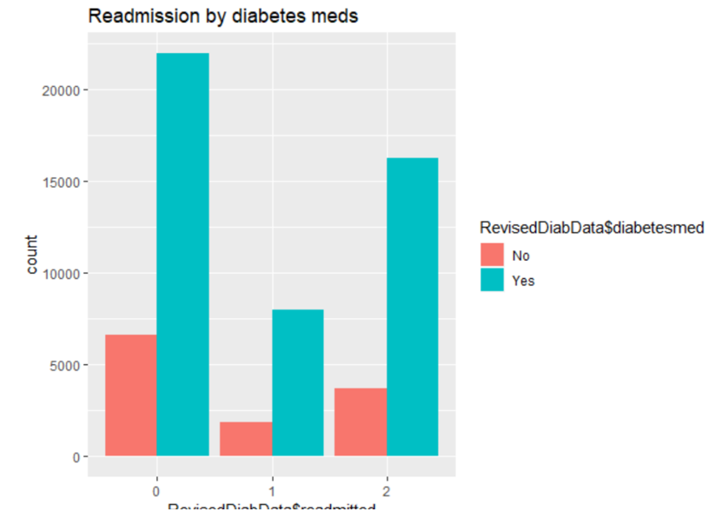

Many more charts were plotted for the attributes like readmission rates by discharge disposition id, readmission rates by admission source id, readmission rates by the number of emergency visits, readmission rates by a1c test results. Next, a correlation matrix was visualized to understand the correlations between integer variables and possibly eliminate one of the pairs with high correlations.

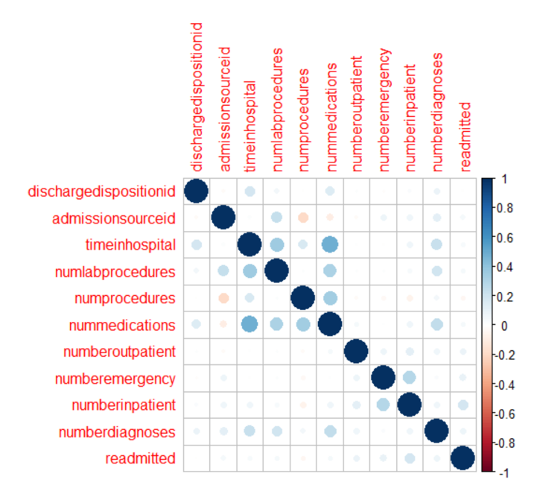

The above matrix shows that there is a strong positive correlation between the variables nummedicationsand timeinhospitaldenoting that when the number of days a patient spends in the hospital increases, the number of medications administered to the patient also increases which makes intuitive sense. So, removing one of these variables for further analysis will prevent skewing. Variable nummedications was removed in this case.

## Models:

After doing the exploratory data analysis, some of the unsupervised and supervised methods were applied to this dataset.

**Association Rule Mining Technique:**

To run the apriori algorithm on a dataset, all the variables should be of factor datatype or only those variables that are factors should be used. Once the required packages (arules, arulesviz) were loaded, the algorithm was run on the diabetes dataset with a low support value of 0.001, high confidence of 0.08 and the minimum length of the rules set to 2. Also, the right-hand side of the rule was set to the readmittedcolumn to find out what factors drive patients to get readmitted to hospitals in less than 30 days and the left-hand side was set to default. The resulting output was sorted by confidence and the top 20 rules were viewed.

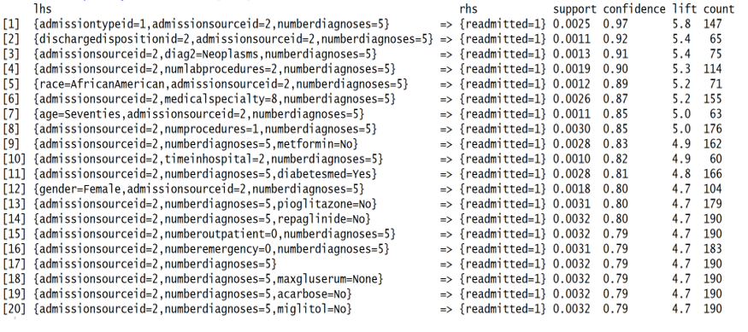

Some interesting associations were identified from these rules.:

Rule 1: shows that when the patient is admitted through emergency and was transferred from another hospital\facility into this hospital and when the number of diagnoses made on the patient is equal to 5, there is a 97% confidence level of patients getting readmitted. The high lift for this rule is 5.8 signifies the high probability of the LHS and RHS factors occurring are dependent on one another.

Rule 2: shows that when the hospital discharges the patient to another hospital and when the patient was transferred from another hospital\facility into this hospital and when the patient has at least 5 diagnoses, there is a 92% chance of patients getting readmitted to the hospital.

Rule 5: shows that African American patients who were transferred from another hospital with at least 5 diagnoses have 89% chances of getting readmitted.

The algorithm was run again by setting the readmitted variable on the right-hand side to be set to 2 (meaning those records where the patients were readmitted to the hospital greater than 30 days of being discharged).

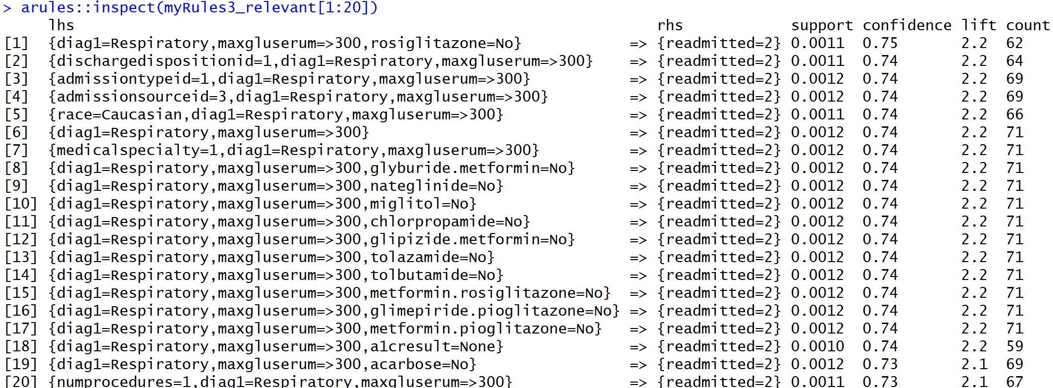

The reasoning behind using this logic to generate rules based on readmission rates greater than 30 days is to see what factors drive the patients to not get readmitted sooner but later.

It can be inferred that there is a 75% probability of patients primarily diagnosed with respiratory illness with their glucose serum levels being greater than 300 and who were not administered with the medicine rosiglitazone getting readmitted more than 30 days of being discharged. Almost all the top 20 rules here show that the patient primarily diagnosed with respiratory illness with a glucose serum level greater than 300 has been readmitted after 30 days of being discharged. Below is the visual graph of the rules. All of them show high support and lift value as well.

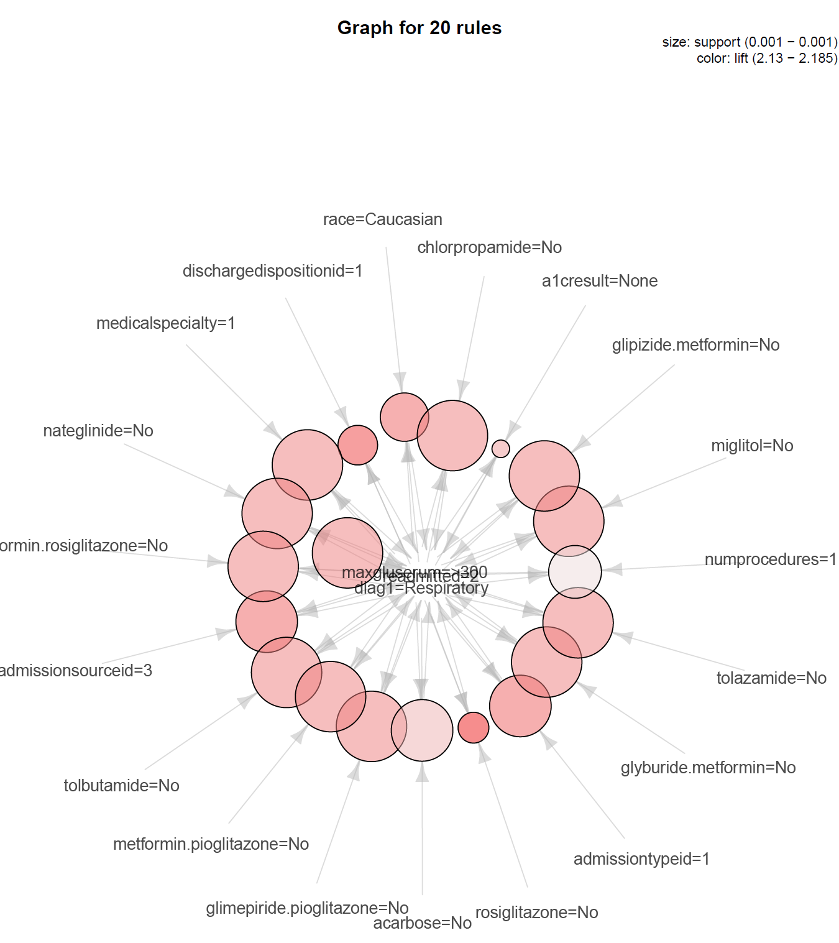

**Clustering Techniques:**

For the analysis of the dataset in question, the K-means clustering technique was chosen. Note that for clustering, one cannot use the same preprocessed dataset as the ARM since all variables were converted to factor type. In order to determine an optimal number for K, an elbow plot was created.

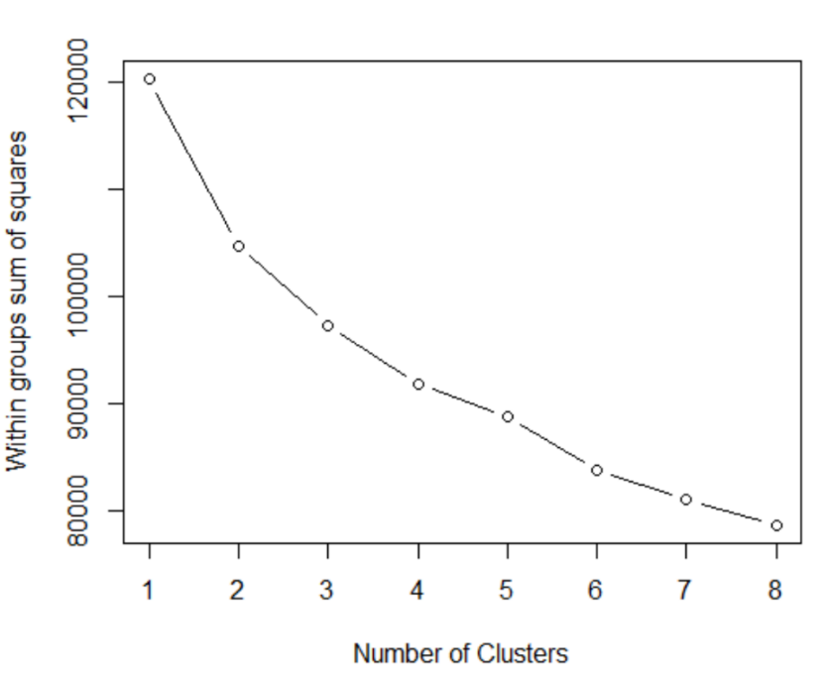

The above plot shows that the optimal number would be 4 or 5 where the line seems to have a downtick.

Keeping K=4, the K-means function is used to see the clusters. This produces a Sum of Squares Error (SSE) of 22.8%. fviz cluster plot from the package factoextra was used to visualize these clusters.

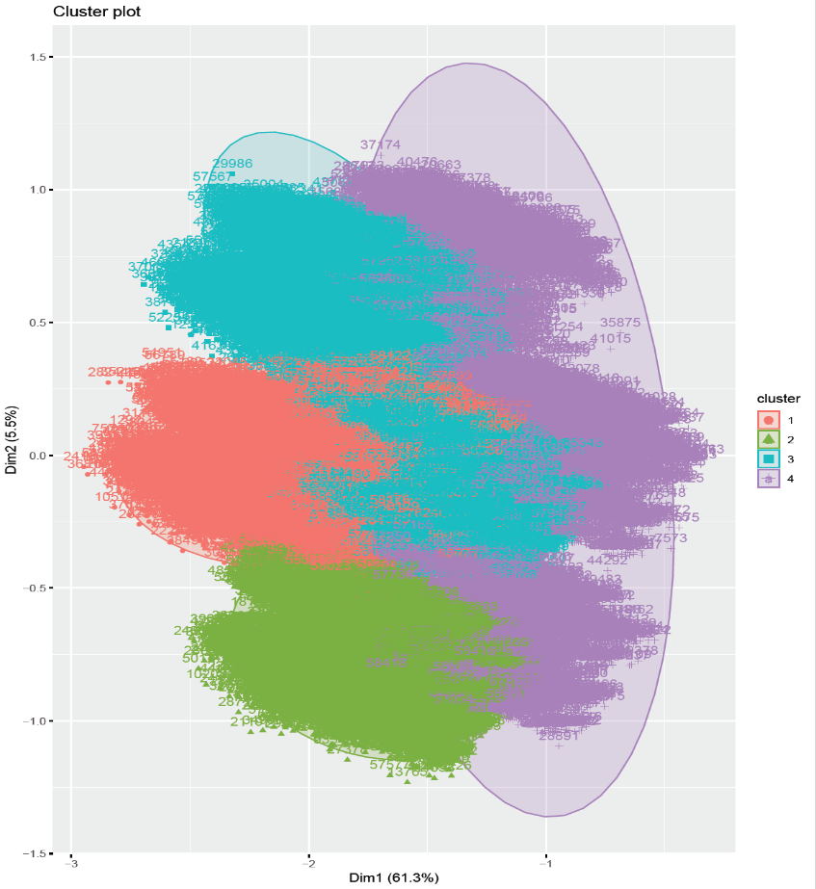

The cluster plot above is formed by using dimensionality reduction where the function combines all the variables and squeezes them into two dimensions which explain about 66.8% of the variability in the features. An inference that can be drawn from the above plot is that the patients in cluster 2 have greater similarities to one another but patients in other clusters are highly overlapping and show that there is not enough dissimilarity between the patients to cluster them separately.

But when K was set to 5, the cluster plot that is seen below shows that clusters 2 and 3 were able to separate themselves and form identical object clusters whereas the other 3 clusters are overlapping on these two clusters.

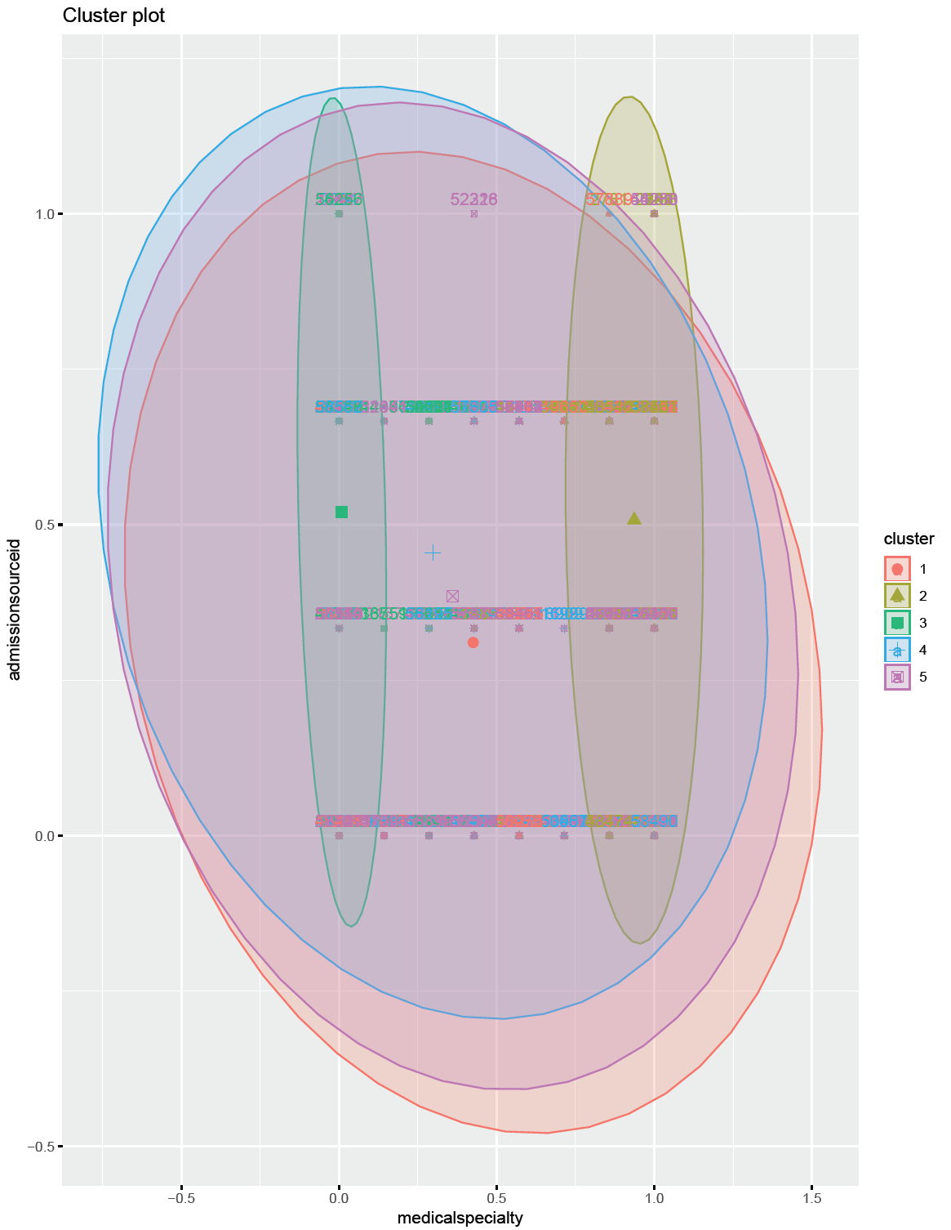

When K was reduced to 3, once again, there were two clusters formed that have considerable distance from one another but cluster 3 overlaps on the other two clusters. The resulting plot is shown below.

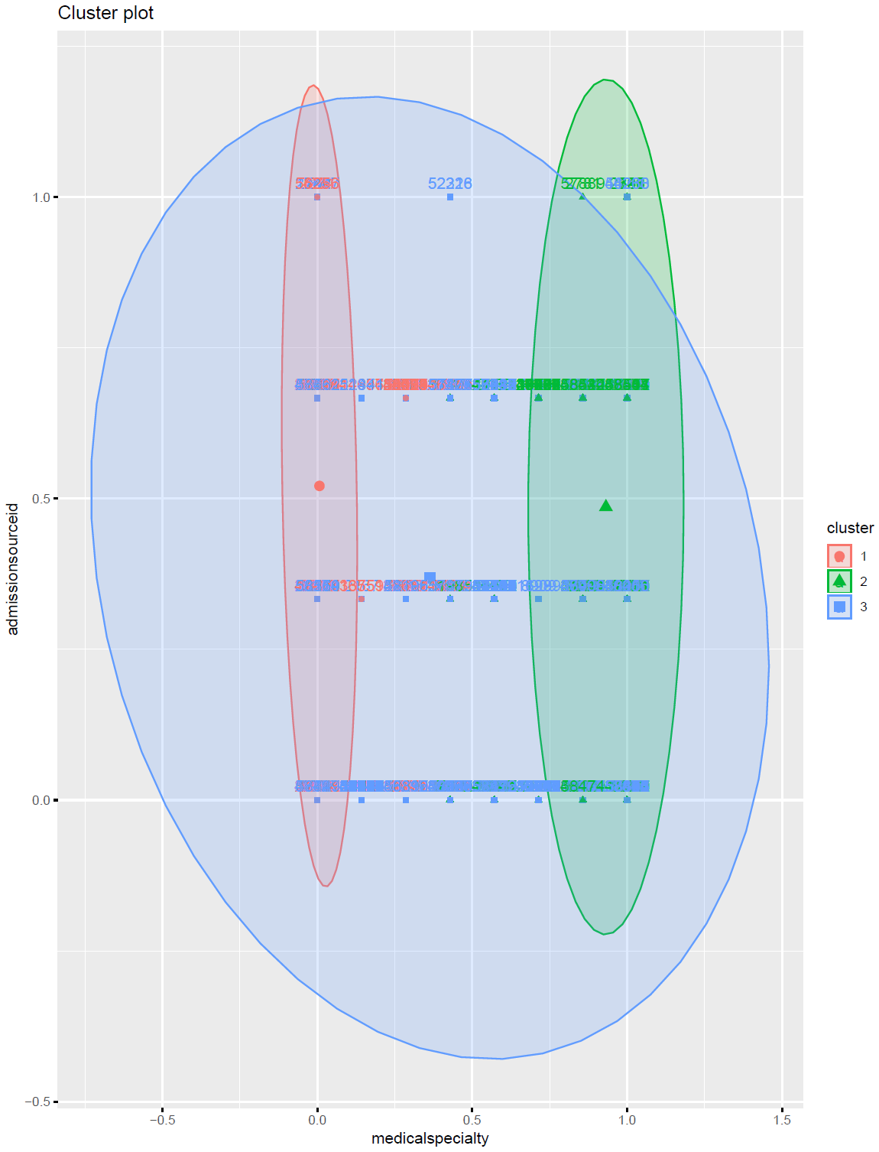

## Classification Techniques:

**Decision Tree:**

The dataset was processed a little differently so that the results of the decision tree can be interpreted easily instead of reading numbers on them. The column medicalspecialty was recoded to names and so were the columns like numprocedures, numlabprocedures, timeinhospital, dischargedispositionid, admissionsourceid, numberoutpatient, admissiontypeid, numberinpatient, numberemergency, numberdiagnoses, and the final prediction column readmitted.

Two different datasets were used to generate the decision trees to see if that affected the accuracy rates. One was the normalized data set that was used in the previous technique and another is the dataset of factor datatype which has levels for every variable.

As it is required for every classification technique, the dataset was divided into train and test sets. Below is a snapshot of the number of rows present in each of the training and test sets.

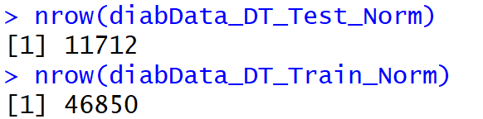

It is also very important that the labels are taken off the test set so that the predictions are not biased.

The below decision tree was created by using the normalized train dataset where the Y variable is the readmission column and the rest of the variables are used as the training variables to predict the readmission column. Rpart function was used with specific parameter tuning like the minimum split, minimum bucket and cost parameter to get better results.

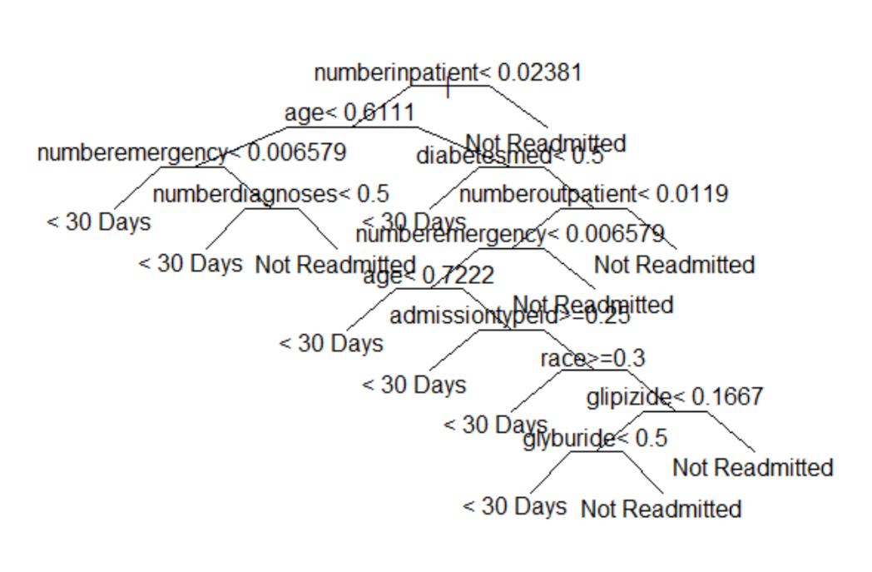

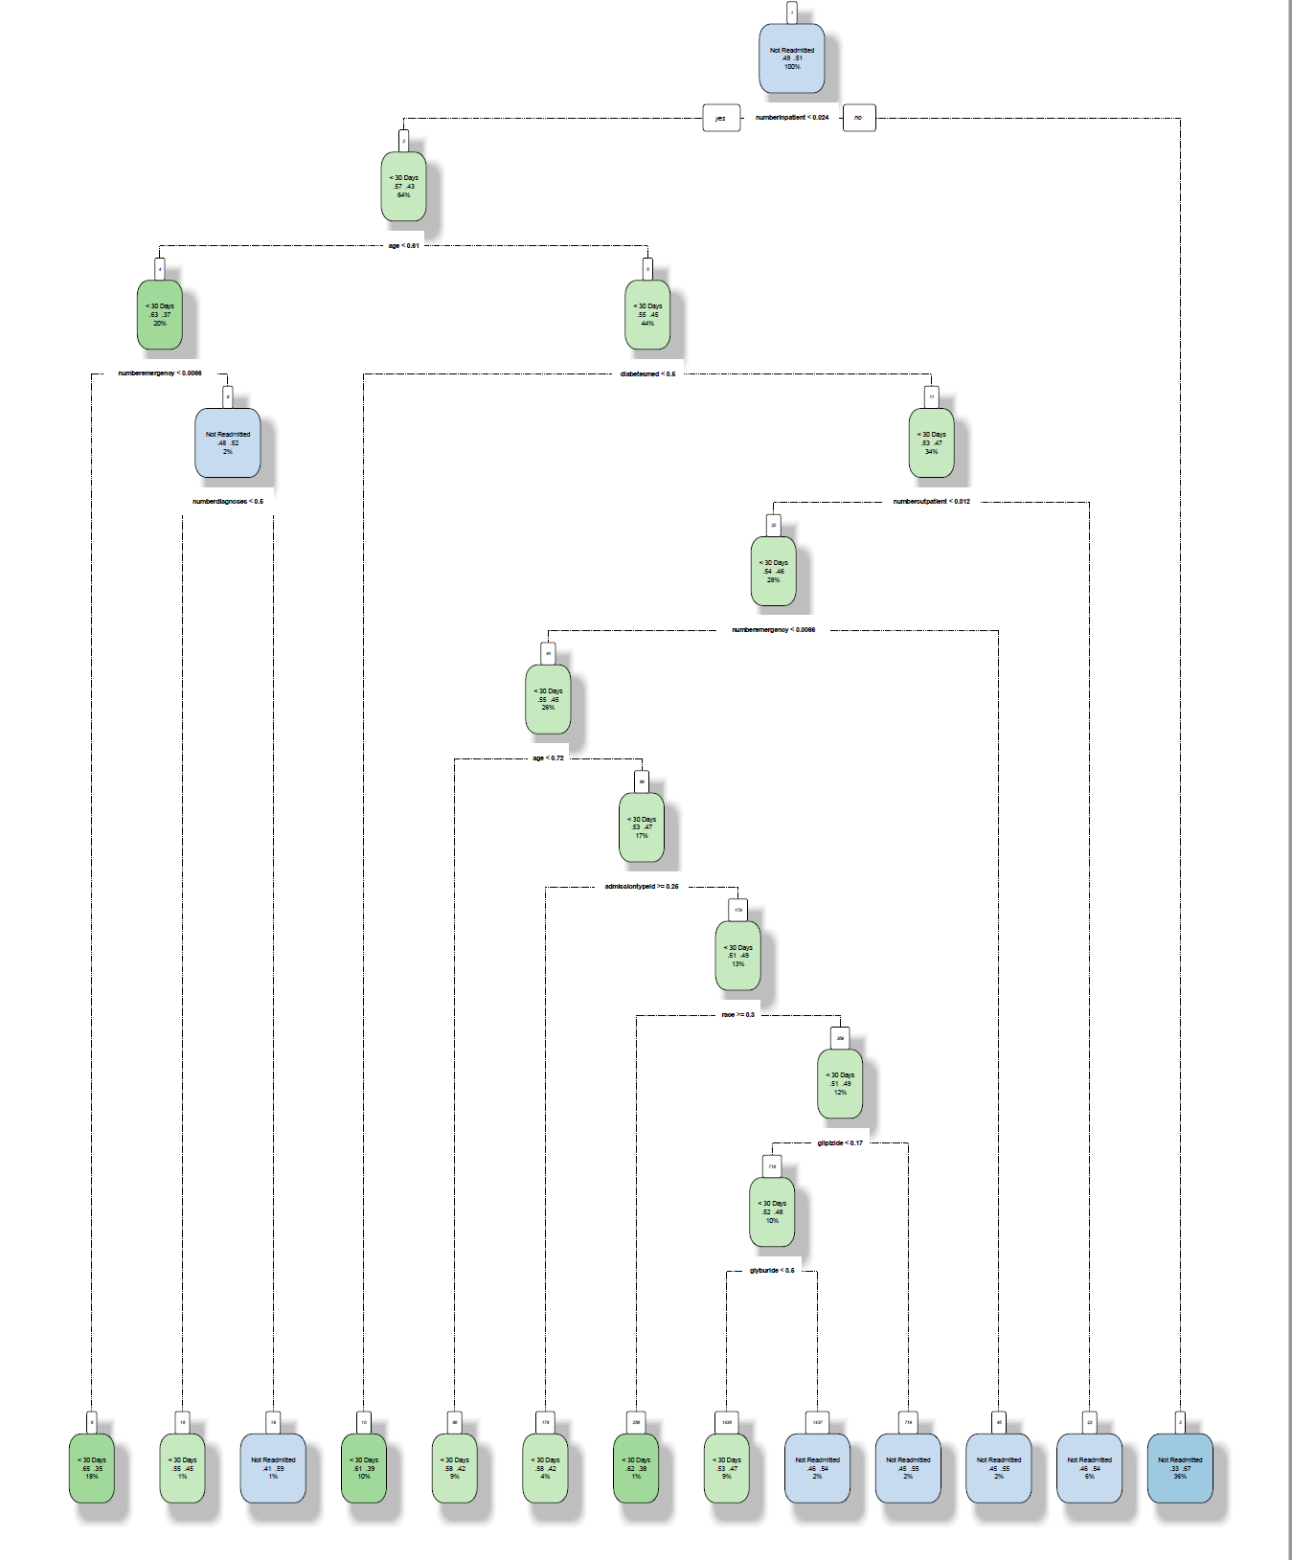

The same parameters were applied to the categorical dataset to see if it got better accuracy rates.

**Naïve Bayes Classifier Algorithm:**

The normalized dataset that was used for the decision tree generation is used for this algorithm as well. The naiveBayes function from e1071 package was used to train the training dataset. First, the model was trained using all the variables as X variables and keeping the *readmitted* column as the Y variable. Once the model was trained, it was used on the test dataset to predict the *readmission* column. An accuracy of 60% was achieved on the predictions.

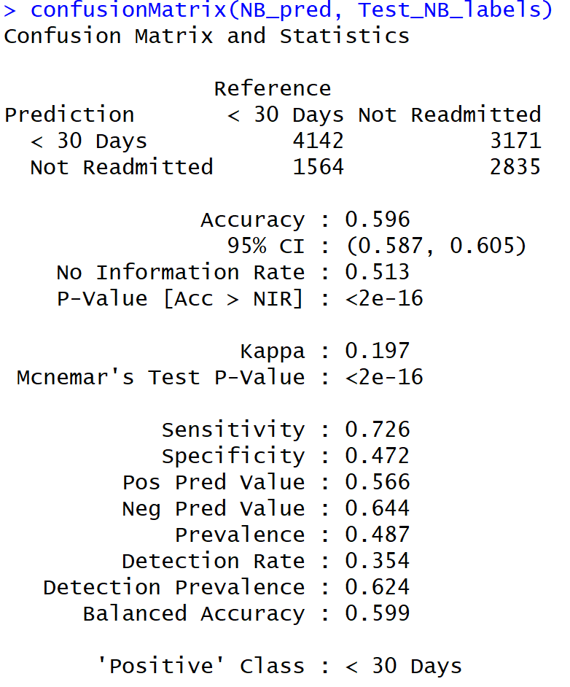

Next, the function InfoGainAttributeEval was used to filter out those attributes with the highest information gain and these variables are selected for the next model to see if better prediction accuracy rates can be achieved. The below bar plot shows the variables with the information gain values where numberinpatient, numemergency, and numoutpatient variables have the highest information gain. Using just these variables, another naïve Bayes model was built using the normalized training dataset.

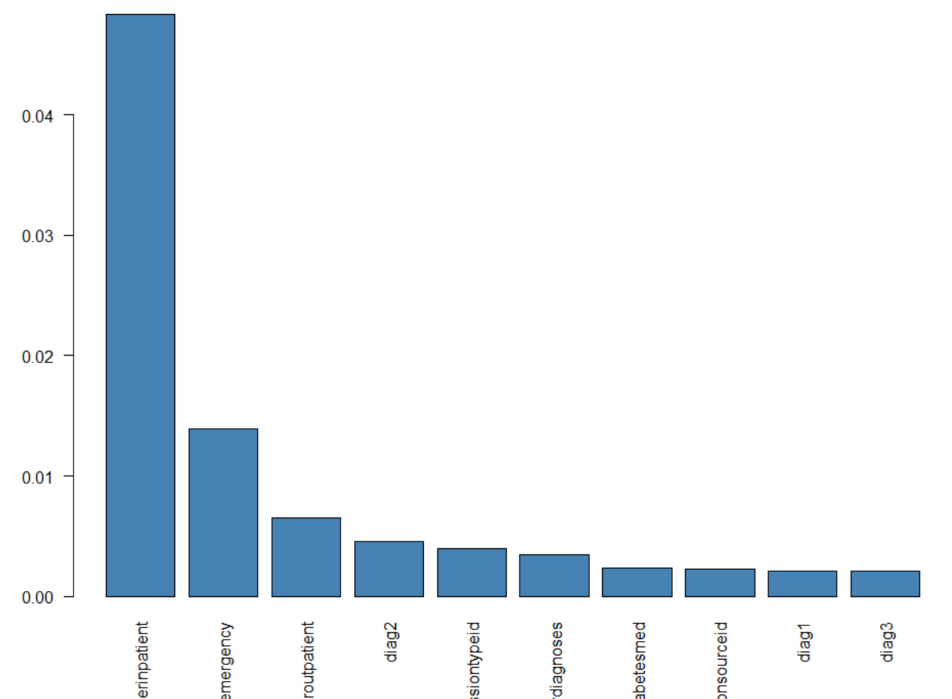

A different function from the klaR package was also used to see if accuracy rates will go up. But that didn’t provide any better result either. In fact, the accuracy rates went further down to 55%.

Also, some density plots were generated using the NB model to understand the effect of the variables on the model. Below are the different plots for each of the variables.

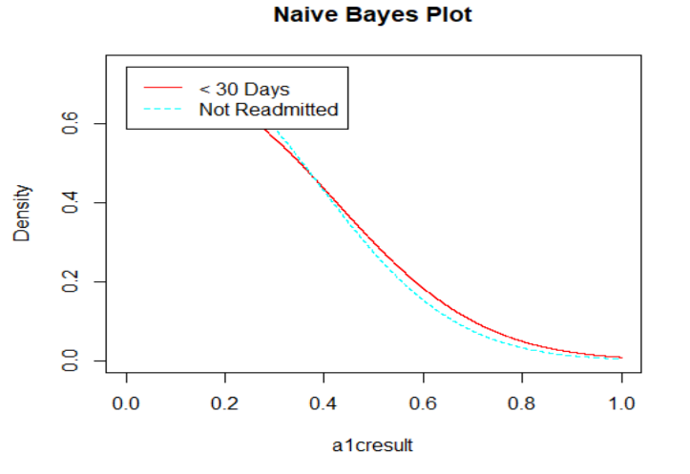 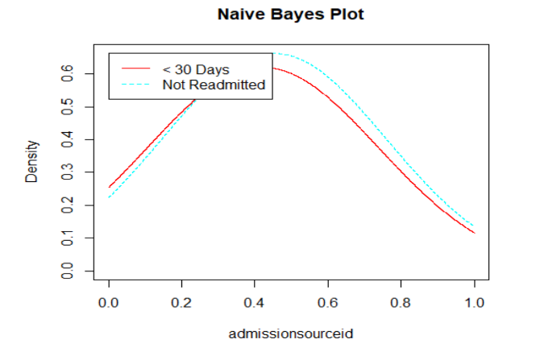

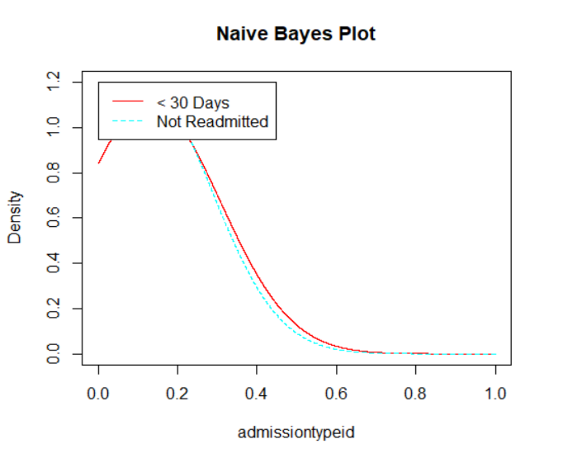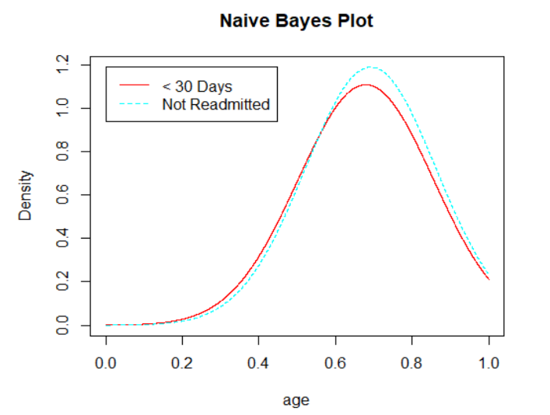

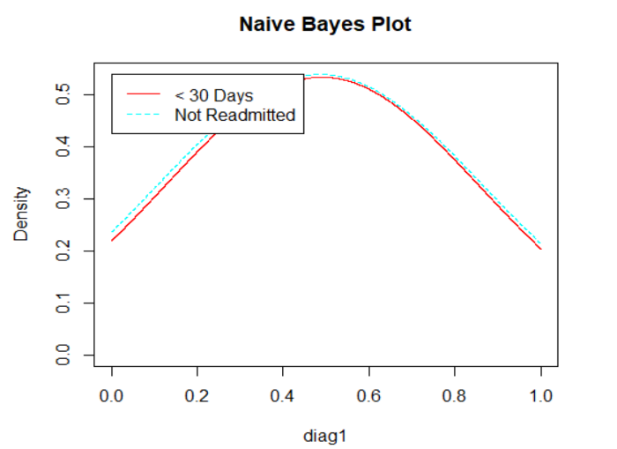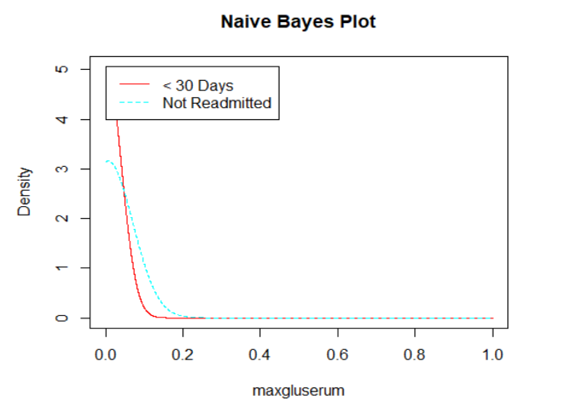

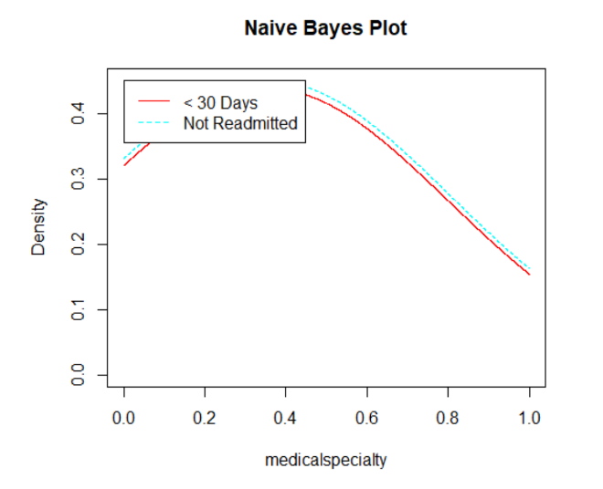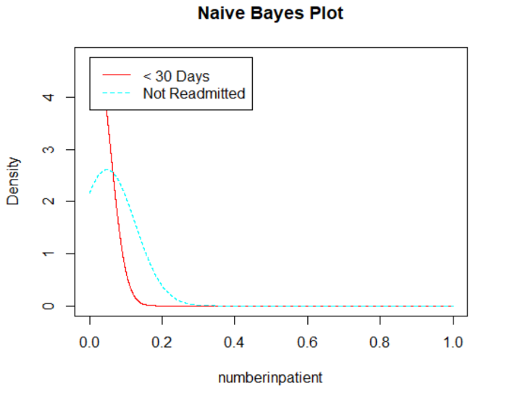

The below quadrant plot shows the intensity of the predictions of the first model that was built with all variables. It is easier to comprehend and say that the model was able to predict more accurate records of readmission than inaccurate records. But, the accuracy and inaccuracy of predicting the ‘no readmission’ rates are almost equal, and it must be improved.

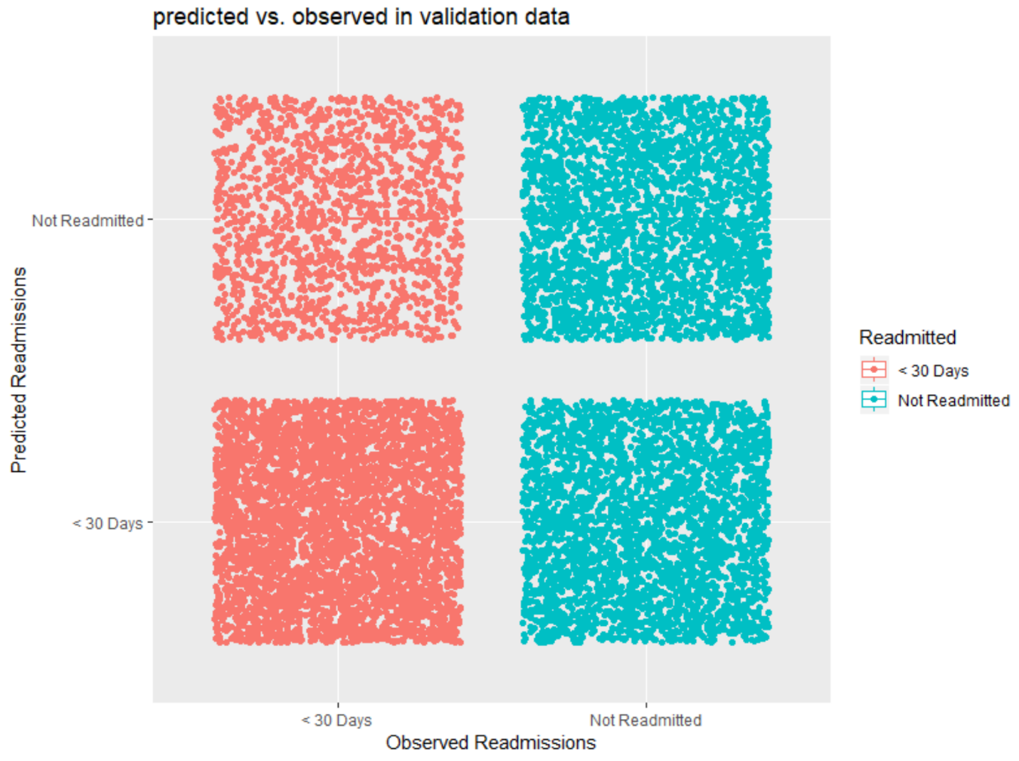

Reducing the number of variables used to train the model did not improve the accuracy rates. The accuracy rate came down to 57% which is not any better than the previous model. Even selecting the numberinpatientvariable as the main variable didn’t improve the results.

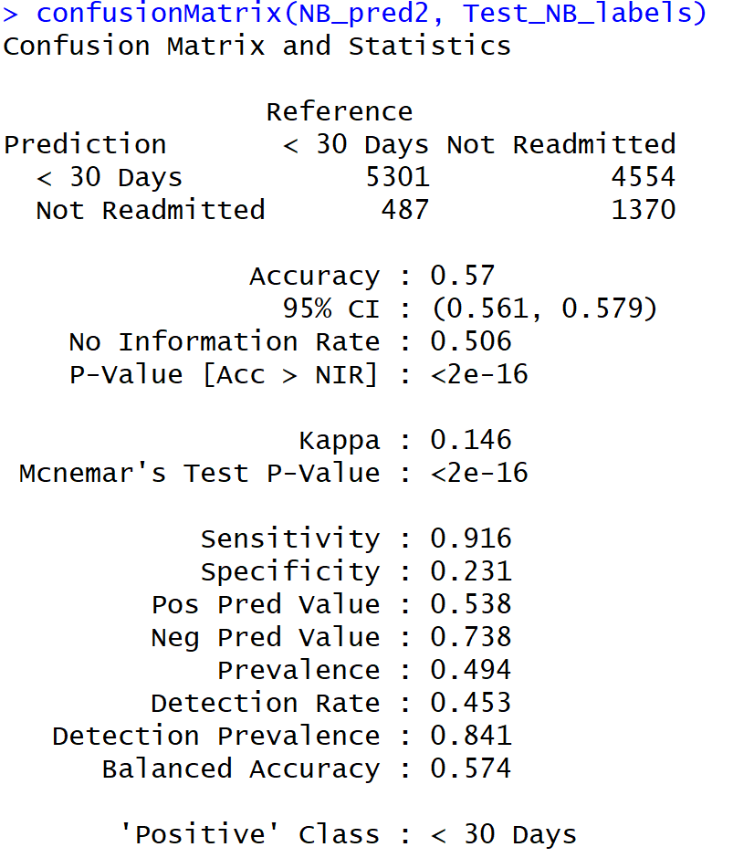

**Support Vector Machine Algorithm:**

The SVM model was applied to the same normalized training data that was used for the previous two classification techniques. Different parameters were tuned to predict the readmission rates. First, the polynomial kernel was used with a cost of 0.1 and the model was trained. This model was used on the test dataset to predict the class labels and a confusion matrix was calculated. The misclassification error rates were also calculated. Below are the results.

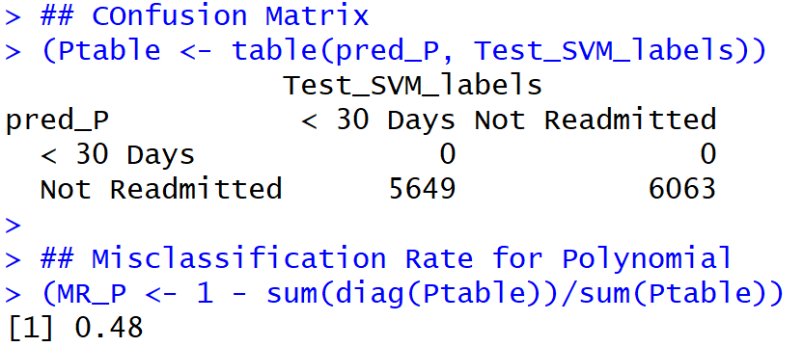

This kernel produced a high misclassification rate of 48% which is not useful at all.

Next, the parameter was tuned to use the linear kernel with the same cost and the misclassification rates were calculated again. Now, the misclassification rate went down to 40% which is better than the previous kernel results.

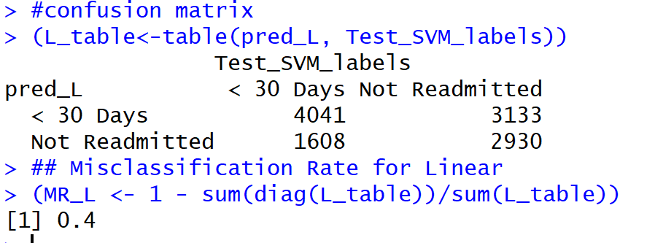

The parameters were once again tuned to use the radial kernel at the same cost to predict the readmission rates. The misclassification error rate is 43% and it performed better than the polynomial kernel but is not as good as the linear kernel.

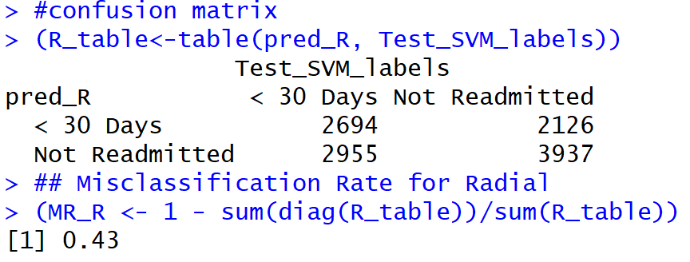

The below plot shows the prediction rates of the SVM model with linear kernel and using all the variables as input. Even though a 60% accuracy rate is not that great, this is still better and useful than the models trained with the other two kernels. Just like the NB model, the SVM model also was able to predict a greater number of accurate predictions for the readmissions than the ‘no readmission’ rates.

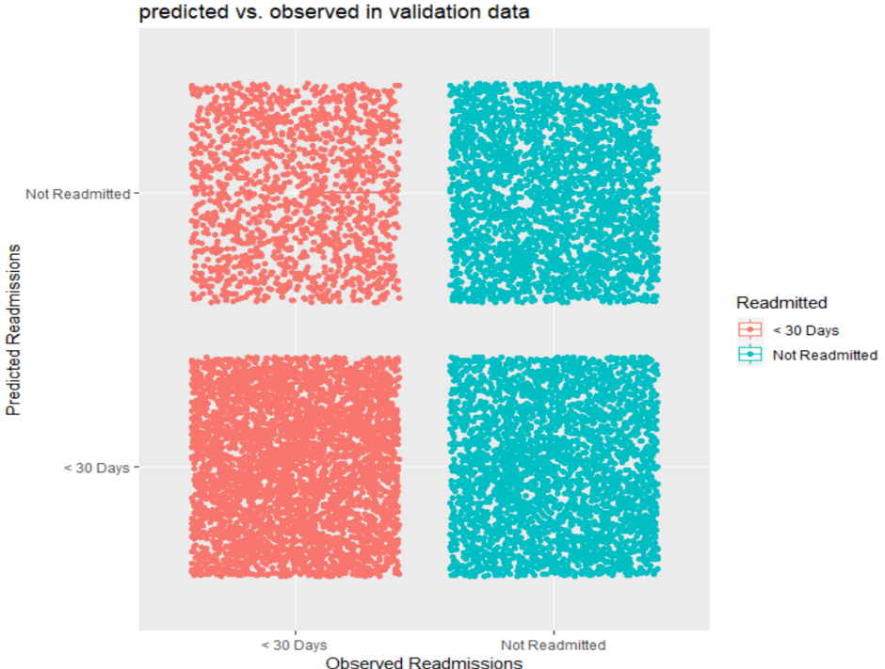

## Ethical Dimension:

Even though the data used in the project was highly sensitive, but it does not contain any personal details like name or phone number or home address, through which an individual can be identified. It mostly contains the different characteristics and hospital admission details of the individual.

# IST 659 - Database for an Online Pizza Company

The objective of the project was to build a database pizza company for online ordering application. It starts with guest customer entry details or new customer register first time on the webpage by providing the name, address, email, and phone number. After successful registration, customer can select pizzas of different sizes and toppings limited to 10 toppings. Customer can select other products present from the product page and can increase or decrease the quantity or remove the item. Only one coupon can be added to an order. A coupon can be either order type or item type. After selecting one or more products and adding in the cart, customer can choose the order destination as either carryout or delivery. After selecting the destination, the customer can choose the order ready date as the current date or future date or future time. After selecting the date/time, the customer needs to select payment methods (one or more payments are applicable). The different type of payment types is Cash or Credit Card. When selecting cash, the customer needs to enter only the amount. For credit cards, the customer has to enter the card number, expiration date, CVV, name in the card, billing address. Once the card number is entered, card type will be auto-selected and the correct card name will be displayed. The customer has the option to save a maximum of 3 cards in the customer account. After selecting the payments, the customer has the option to review the order before confirmation. Click on Confirm Order button and an order confirmation number is generated in the webpage and an email is sent to the customer in the registered/given email.

## Conceptual Model:

First, all the entities and the attributes are created and the required and required unique attributes are identified for each entity. Then a conceptual model was created using the entity-attribute table.

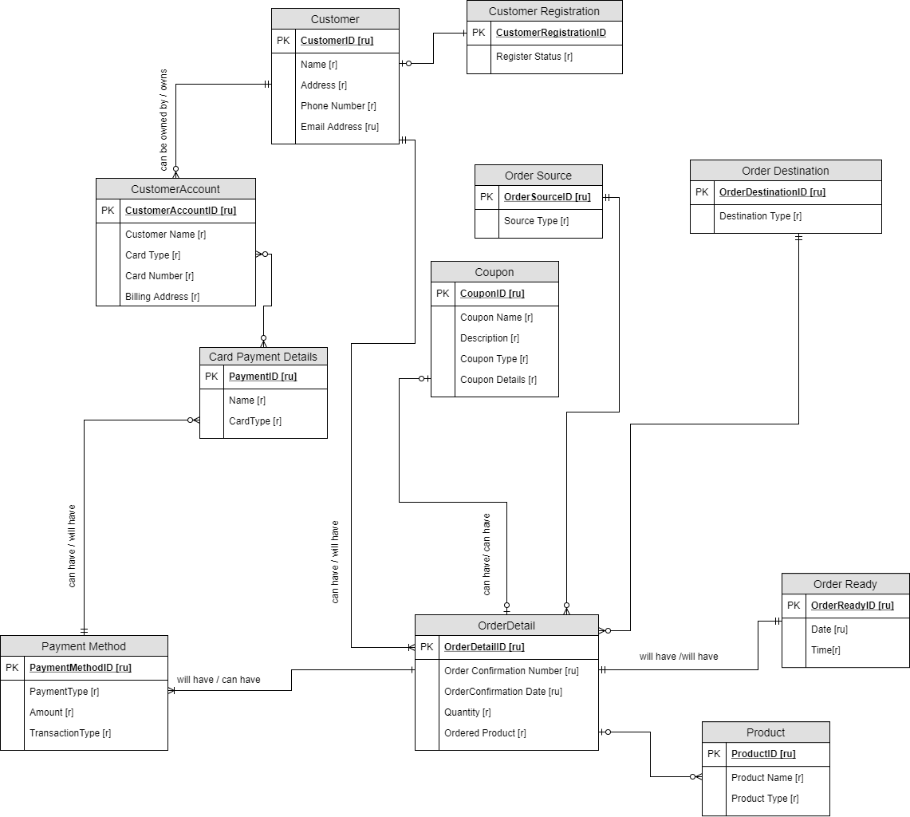

## Normalized Logical Model:

The conceptual model was then normalized and a normalized logical model was created by defining all the columns, primary key, foreign keys, and the relationships as shown in below picture.

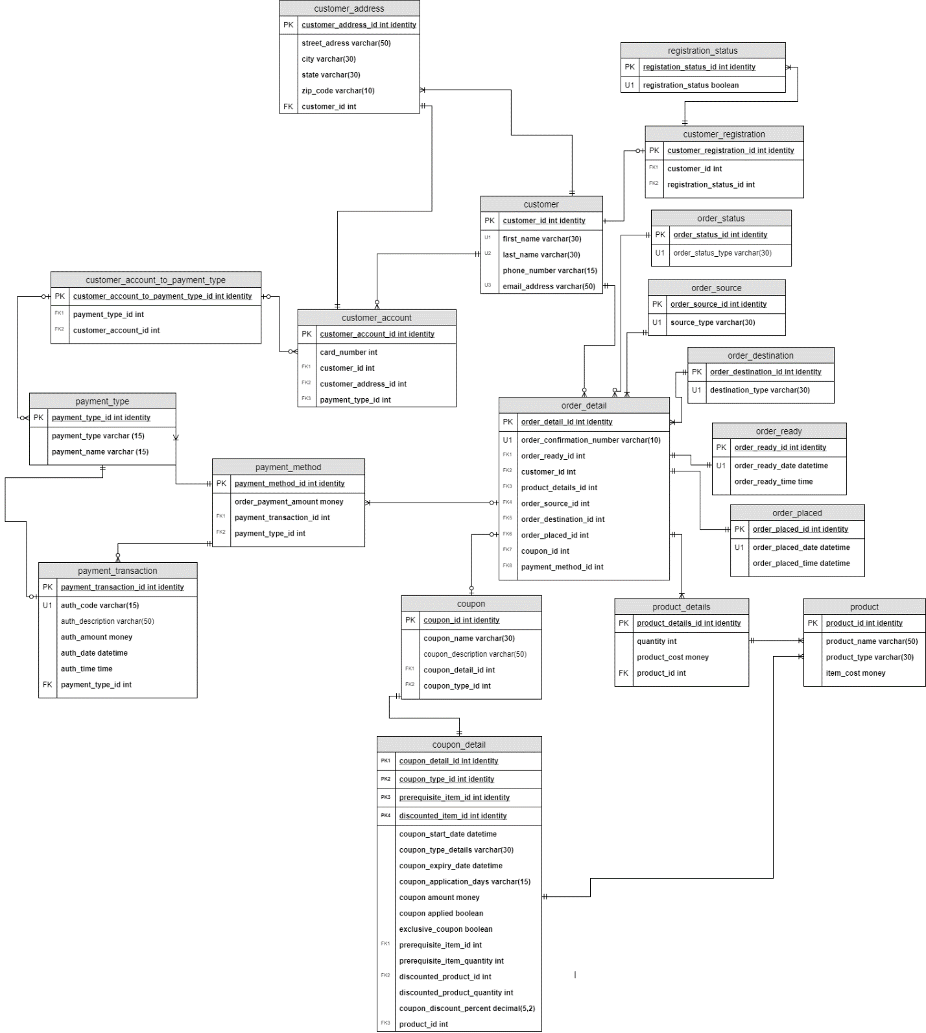

## SQL DDL Commands:

Once the normalized logical model was created, then SQL DDL commands like creating tables using constraints, stored procedure to create tables, create view, create functions were applied.

**SQL DDL Commands**

-- Creating customer table

create table customer(

customer_ID int identity

,first_name varchar(30) not null

, last_name varchar(30) not null

, phone_number varchar(15) not null

, email_address varchar(50) not null

-- Constraint on the customer table

constraint PK_customer primary key (customer_ID),

constraint U1_customer unique (first_name),

constraint U2_customer unique (last_name),

constraint U3_customer unique (email_address)

)

-- End creating customer table

-- Creating customer address table

create table customer_address(

-- Columns for customer address table

customer_address_ID int identity

,street_address varchar(50) not null

, city varchar(30) not null

, state varchar(30) not null

, zip_code varchar(10) not null

, customer_ID int not null

-- Constraints on the customer address table

constraint PK_customer_address primary key (customer_address_ID),

constraint FK1_customer_address foreign key (customer_ID) references customer(customer_ID)

)

-- End creating customer address table

go

-- Stored Procedure to create new customer

create procedure new_customer(

@firstname varchar(30),

@lastname varchar(30),

@phonenumber varchar(15),

@emailaddress varchar(50)

) as

begin

declare @customerID int

-- Get the customer ID from the customer table and store it in @customerID

select @customerID = customer_ID from customer

where customer_ID = @customerID

-- Insert new customer record in customer table

insert into customer(first_name, last_name, phone_number,email_address)

values (@firstname, @lastname, @phonenumber, @emailaddress)

-- increment customerID using @@identity

return @@identity

end

exec new_customer 'Katrina','Adams','7876650091','kadams@syr.edu'

go

-- Stored Procedure to create customer address

alter procedure customeraddress(

@streetaddress varchar(50),

@city varchar(30),

@state varchar(30),

@zipcode varchar(10),

@customerID int

) as

begin

declare @customeraddressID int

/*

Get the customeraddress ID from the customer adress table

by joining the customerID of customer

table with customer address table

and store it in @customerID

*/

select @customeraddressID = customer_address_ID

from customer_address

join customer

on customer.customer_ID = customer_address.customer_ID

go

-- Create view to see customer address and registration status

create view customer_registration_details as(

select customer.first_name

, customer.last_name

, customer_address.street_address

, customer_address.city

, customer_address.state

, customer_address.zip_code

, registration_status.registration_status

from customer

join customer_address

on customer.customer_ID = customer_address.customer_ID

join customer_registration

on customer_registration.customer_ID = customer.customer_ID

join registration_status

on registration_status.registration_status_ID = customer_registration.registration_status_ID

)

go

-- Create function to multiply quantity with product price

create function product_price(@quantity int, @itemcost money)

returns money as

begin

declare @returnvalue money

set @returnvalue = @quantity * @itemcost

return @returnvalue

end

## SQL DML Commands:

Then SQL DML commands like insert statements, and select statements were triggered.

--Insert status in registration status table

insert into registration_status(registration_status)

values (1)

-- Insert record in customer registation table

insert into customer_registration (customer_ID, registration_status_ID)

values(1, 2)

insert into customer_registration (customer_ID, registration_status_ID)

values(2, 2)

insert into customer_registration (customer_ID, registration_status_ID)

values(3, 2)

insert into customer_registration (customer_ID, registration_status_ID)

values(4, 1)

insert into customer_registration (customer_ID, registration_status_ID)

values(5, 2)

insert into customer_registration (customer_ID, registration_status_ID)

values(6, 1)

insert into customer_registration (customer_ID, registration_status_ID)

values(7, 2)

insert into customer_registration (customer_ID, registration_status_ID)

values(8, 2)

insert into customer_registration (customer_ID, registration_status_ID)

values(9, 1)

insert into customer_registration (customer_ID, registration_status_ID)

values(10, 2)

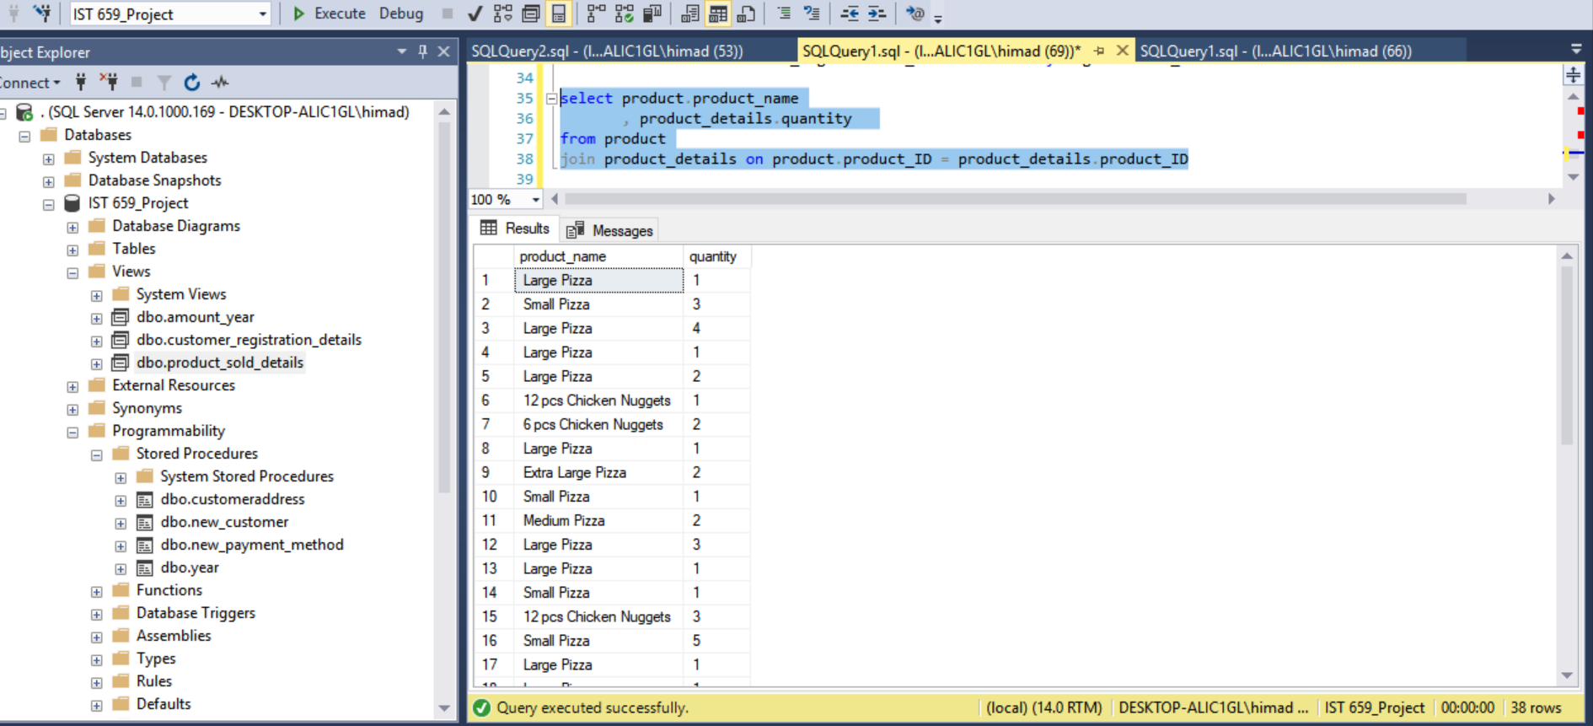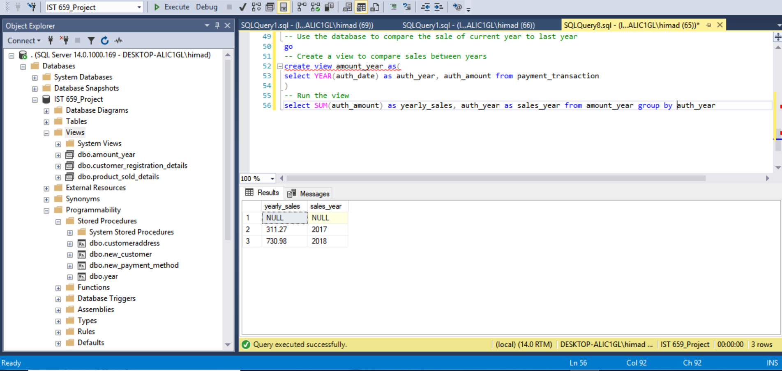

## GUI Prototype:

Using RODBC package, a connection was established to SQL Server using 64-bit DSN and the following bar charts were plotted on R.

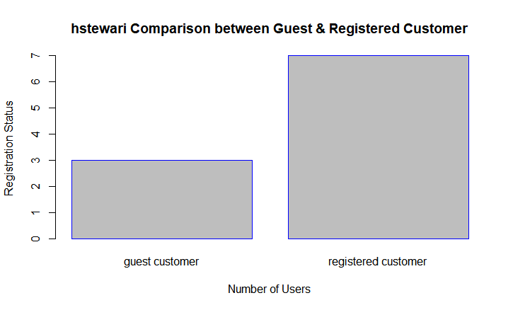

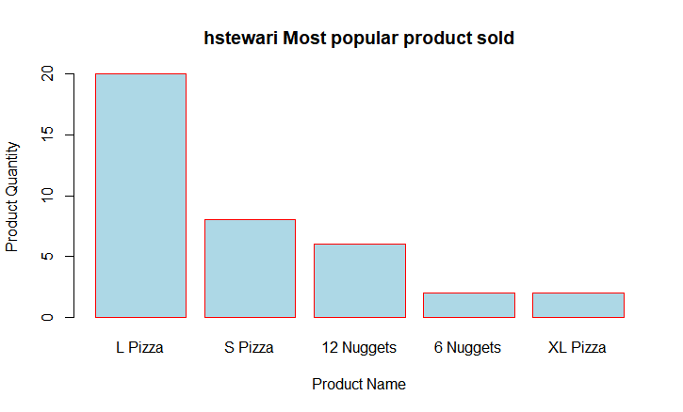

## Ethical Dimension:

The database was created using a very common concept of the pizza company and the data stored are not real-time data and are mostly test data used to create the database. It would not affect any pizza making company.

# Conclusion

The portfolio demonstrated the learning objectives and the competency I have achieved from the major practice areas in data science. I have collected the most of the data for the project from the online communities and web platforms to analyze and identify the trends and patterns and applied statistical methods and machine learning techniques to do predictive analysis (refer to project IST 652, IST 707 & IST 736). I have also learned to collect and organize the data using various database solutions like Microsoft SQL Server and Mongo DB (IST 659 & IST 652). I have also implemented various data visualizations along with data mining techniques to identify the patterns in the data and based on the analysis, provide suggestions and recommendations to implement business decisions (refer to project IST 736 & IST 707).

I have also developed communications skills during my journey and demonstrated during the presentation where I have presented my analysis of the data in a simple way, so a people from non-technical background can also understand and act upon (refer to project IST 652, IST 736 & IST 707). Regarding the ethical dimensions of data science practice, I have always collected the data which does not contain any sensitive and personal information. Any sensitive information present in the data were thoroughly analyzed and excluded before using for the projects. These are representative of the successful execution of the learning objectives and have developed the necessary skills for practice in the field of data science.

During my learning program, I have not only learned the application of data science practice and processes but also gained technical, analytical and communication skills to apply analytical concepts on the data, analyze the data and communicate my analysis for decision making.